For the preparation of the new student’s registration, and to be able to make the virtual meeting on Microsoft Teams, please proceed before the date of the meeting, you can check below all the information needed.

Sign up for Teams free

Microsoft Teams
- Go to Get Teams for free and choose the Sign up for free button. If you don't see the Sign up for free button, scroll down (nearly to the bottom of the page) to Get Microsoft Teams for your organization today, and then select Sign up for free.
Enter the email address you want to use with Microsoft Teams free. (Hotmail, Outlook, Gmail, etc.)
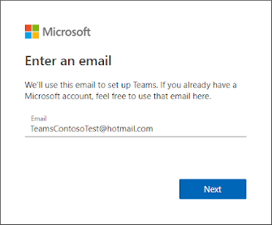
- On the next screen, answer the question about how you want to use Teams.
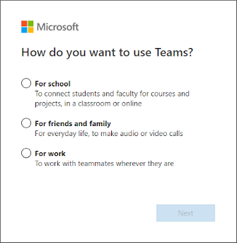
choose For work, and click Next.
- You'll be asked to verify your information again in this step. you'll need to provide your password.

- After that, fill in your name and the other requested info, and then click Set up Teams.
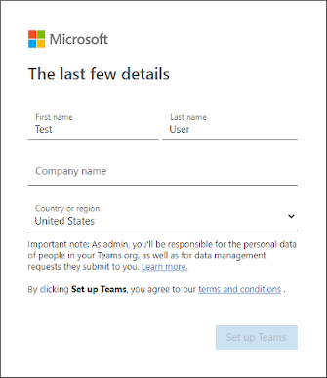
- Then wait patiently while Microsoft creates your Teams account and then sets it up for you to use. (This process can take up to a minute. You'll see two loading screens.)
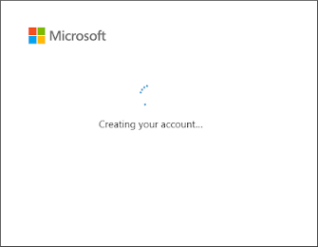
- Finally, you'll be prompted to download the Teams desktop app or use Teams web app.
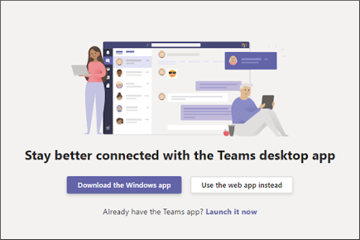
Done you can sign-in to Microsoft Teams now,

Please send us your registration email to:
inscription.sa@besancon.edu.lb

If you have any queries don’t hesitate to call us on WhatsApp, 01372746 our technical department will be at your service,

La Direction.

